MORNING WORSHIP SERVICE
Nov 29, 2015

Opening Song “Old Time Religion”

Opening Prayer/Announcements

Worship Hymns “Go, Tell It On The Mountain” 95
“Silent Night, Holy Night” 91
“Angels, From The Realms of Glory” 94
“Emmanuel” 82
“He Is Lord”

Offering/Offertory

Special Music

Message Bro. David Atwood

Invitation “I Have Decided To Follow Jesus” 305

.

Closing Prayer

No Evening Service

Living Proof Live
March 4-5, 2016 (Fri & Sat)
Waco, TX: Extraco Event Center
Contact Patti Radford if you might be interested in attending

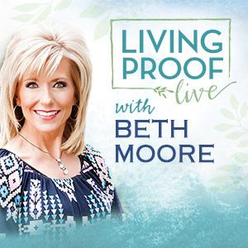
NURSERY – available for children age 0 to Kindergarten
Angie Fisher

Hostesses for November Ushers for November
Shirley Marecle, Judie Coffey, Joe Daniel, Mickey Stanford,
Judy Broussard, Otisann McManus David Condron, Hugo Breithaupt

Immediate Need Prayer List
Prayer & Request Information

(Please complete name & address information on reverse side)

❑ I would like to speak with the Pastor.

❑ I would like more information on this church.

❑ I have Prayer Requests or Needs

Date:

Permission to Publicize:
Church Bulletin  Yes  No
Email Prayer Chain  Yes  No

Prayer Request:

Prayer For
Name
Address
Phone

Given By
Name
Address
Phone
Please Contact By

❑ Card  Phone  Visit

Comments

Pray for Pat Dismukes Murdoch – cancer

Pray for Theresa McCormick (kin to Theresa Bartlett), she was in the hospital having blood transfusions

Pray for the family of Lottie Morton (Geary McManus’ sister), her son passed away

K s b c

Keeping His Word through Sunday School, Bible Study and Church Attendance/Worship

Sunday School Bible Studies for November:

Nov 1st Stand Courageously Daniel 3:13-18,26-28 Nov 8th Live Humbly Daniel 4:28-35 Nov 15th Confront Sin Daniel 5:17-28 Nov 22nd Act Faithfully Daniel 6:6-10,13-16,19-22 Nov 29th When Opposition Strikes Acts 4:23-31

9:45 a.m. each Sunday – A place for everyone

WE’D LOVE FOR YOU TO JOIN US!

